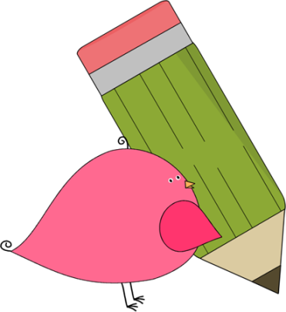

Ms. McRae’s 2nd Grade

Nov. 18 - 22

In class this week:

**Literacy:** Key Details in an Story

**Fundations:** Unit 4 Review – Unit 5

**Writing:** I can write my opinion and give reasons and examples to support it.

**Math:** I can determine addition and subtraction word problems and solve them with the correct strategy.

**Science:** Rotation with SS.

**Social Studies:** Creek and Cherokee

HOMEWORK:

* **Math homework will go home as needed**
* **iReady – 15 minutes in math and 15 minutes in reading**
* **Students may also work on IXL teacher suggestions at home.**
* **MyOn has reading groups for**

**books selected based on each student’s iReady Lexile Level.**

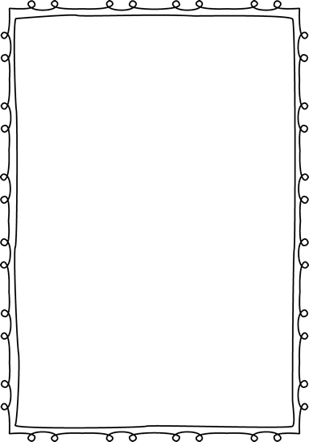



Contact Ms. McRae:

Email: mcraeaj@boe.richmond.k12.ga.us

School Phone:

706-821-2766

Important Dates and Upcoming Events:

* Picture Day – Nov. 20
* Friendsgiving Lunch – Nov. 21
* Fall Break – Nov. 25-29

Announcements:

* Congratulations to Zadon and Zamir Thompson for completing the Brian Jordan Reading Challenge!
* Round 2 of the Reading Challenge has already begun. Please read for 15-20 minutes at home and record the minutes and book on Beanstack. You can also send in the logged minutes and book title and have the students log the minutes in at school. All students know how to do so.



C:\Documents and Settings\Jac\Local Settings\Temporary Internet Files\Content.IE5\OGYR678X\MC900391164[1].wmf